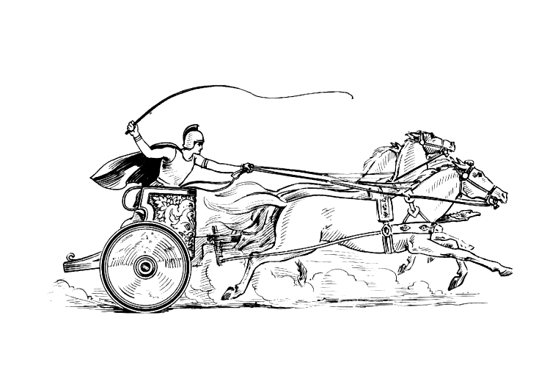
Parish Clerk: Mrs Elane Higgins
Registered Address:
Mancetter Memorial Hall
Old Farm Road
Mancetter.
CV9 1QN
Telephone: 01827 722552
Email: parishclerk@mancetter.org.uk
Website: www.mancetter.org.uk
Manduessedum - Mancetter Village
(Place of War Chariots)
Mancetter Parish Council
Serving the People of Mancetter and Ridge Lane

Mancetter Parish Council where possible uses local contractors (thank you Rob, Barry and John) to maintain to a high standard the picturesque village green, St Peter’s churchyard and Mancetter Cemetery as well as Ridge Lane Allotments and several miles of rights of way and rural footpaths. At the Parish Council meeting on 25th January 2022 after reviewing the draft budget and rising costs, it was unanimously agreed to increase the total annual precept to £32,000. This is an overall increase of £2000.00 equal to a percentage increase of 6.67%.

This sounds a lot as a percentage, but in real terms it works out between 12p and 35p per month per household.
The Parish Council annual increase on Council Tax bands is as follows with a band D property increasing by £2.07p a year.

Council Increase Total Council Increase Total Parish
Tax Band For Year Parish Tax Band For Year Levy
Levy

Band A £1.38 £31.43 Band E £2.52 £57.61
Band B £1.61 £36.66 Band F £2.99 £68.09
Band C £1.84 £41.90 Band G £3.44 £78.56
Band D £2.07 £47.14 Band H £4.14 £94.28

107 shields in 5 different designs, using lightweight reclaimed wood, have been cut out and primed by Parish Councillors Trevor Hopkins and Peter Mann. The plan is to display them during the Jubilee Weekend, on lamp posts around both villages within the parish, using cable ties attached to pre-drilled holes at the top and bottom of each shield. Residents, and Local Community Groups will be asked to help decorate 70 shields for Mancetter (one for each year of the Queen’s reign) and 7 for Ridge Lane (one per decade). The theme will be of something significant for that year or decade and individuals and groups will be able to come up with their own design. Prizes will be available for different age groups, and a history trail can be followed to learn about the people and events that have shaped the last 70 years. The other 30 shields have already began to be decorated by children and community groups within Ridge Lane.

Further details will be available at the Annual Parish meeting open to all on Tuesday 26th April 2022 7pm at St Peter’s Church in Mancetter. We also have a Councillor vacancy if you fancy joining the team.

2,000 tulip bulbs have already been planted around the parish, and on Mancetter Green the number “70” has been laid out with the dates “1952 – 2022” underneath. Seven specialist trees have also been purchased for the cemetery to add to the six purchased in 2012. The planting will create a “Jubilee Avenue” as a lasting commemoration and help with our commitment to protect our environment for future generations of villagers.

